IES SERPIS | INTERFACE DESIGN | 2 DAM

1. Create a window with a button “Introduce your name” and texts for the name and surnames. There is also a JList and a JCombo. When the user presses the button the full name is added to the JList. The JList is multiselection. The selected elements will be added to the JCombo with another button.

2. Create a window that is similar to

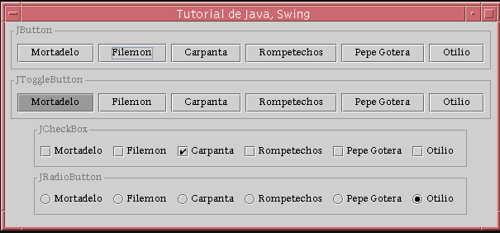
- Create a program similar to this. It doesn´t matter if the button occupies the whole space or the image is not centered.

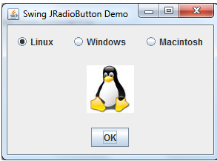
The image changes when we click the radios, and if we press the button

